# Lab 2

## Create and run machine learning job

1. In Machine learning, Job management, create a new job

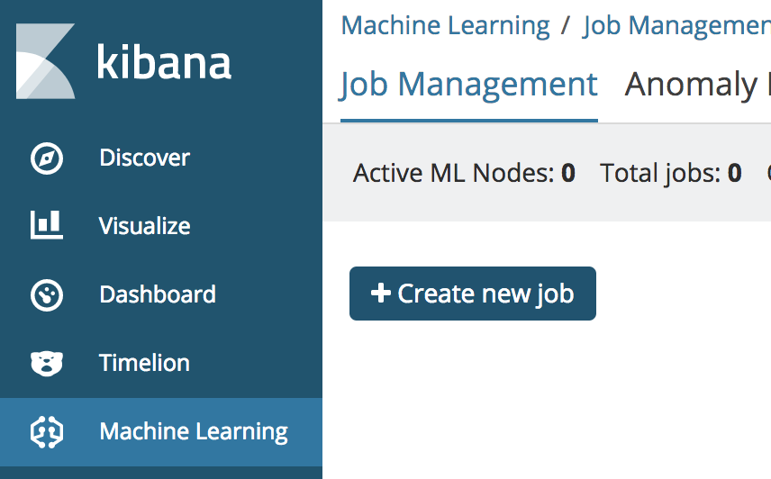

2. Chose farequote index pattern

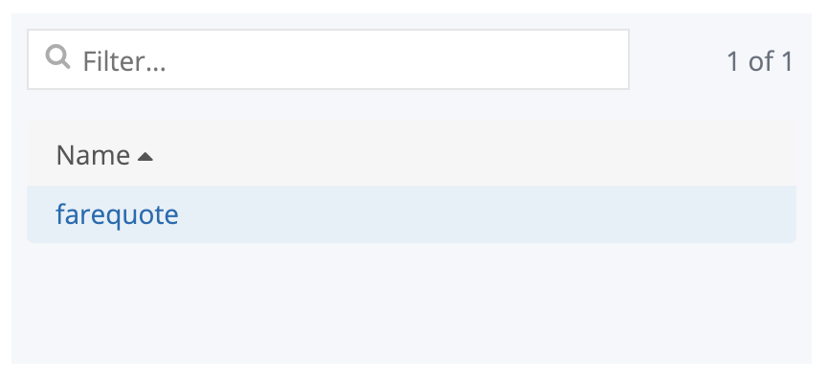

3. Pick multimetric Job wizard

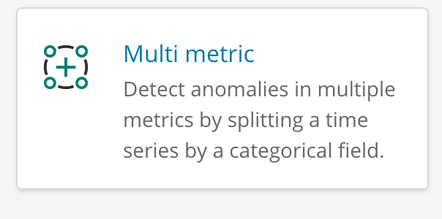

4. Configure the job

* choose event rate: count, responsetime: max
* bucket span: 10m
* Split Data: airline
* click “use full farequote data”
* Name: “farequote_multi”
* click “Create Job”

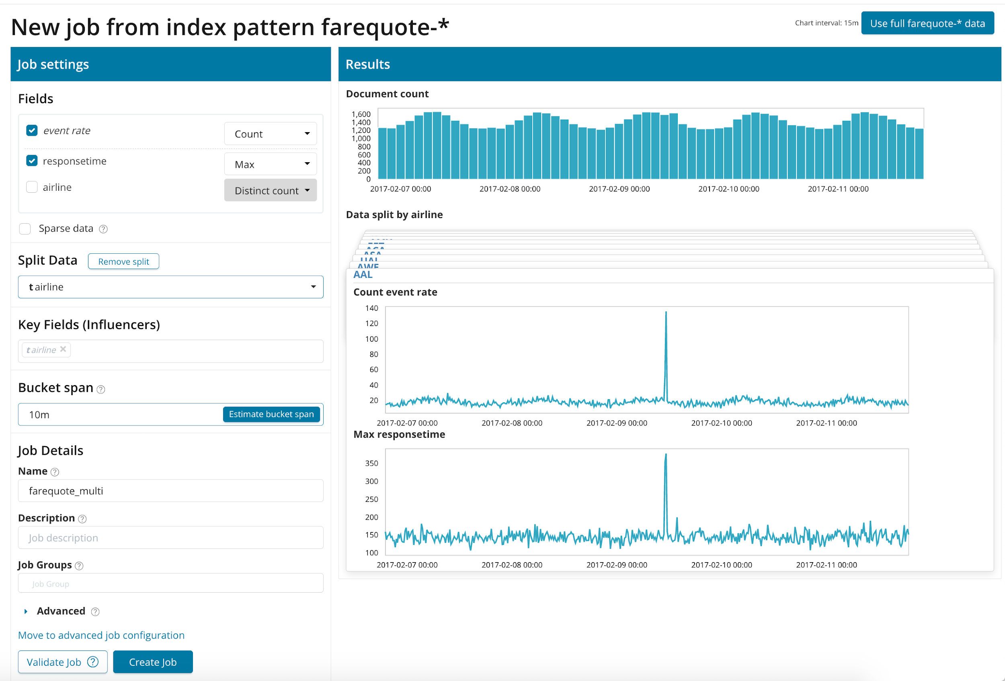

## See animated learning and view results

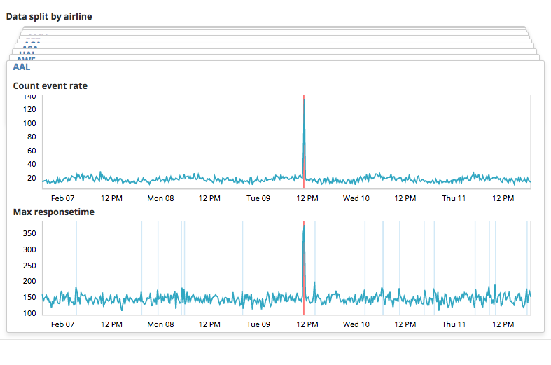

top unusual airline: AAL anomalies in both count and response time

